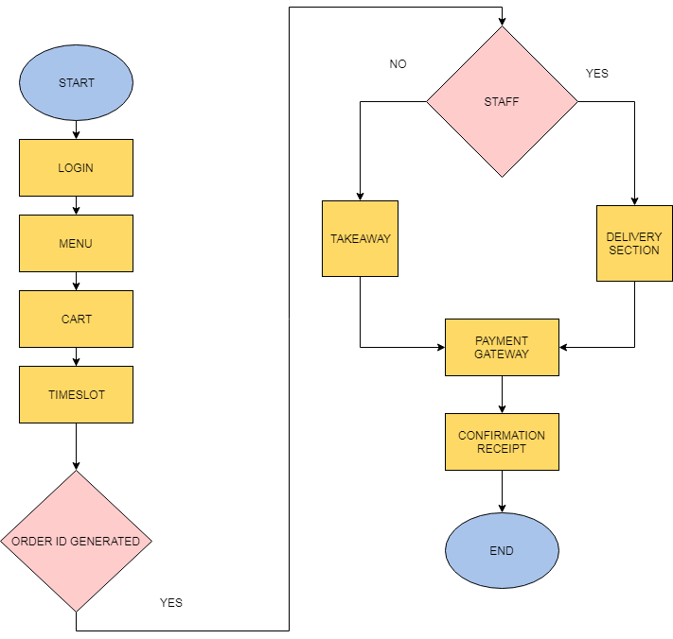

* Automatic synchronization of incoming order with custom attributes like ingredients, serving size, nutrition instructions.
* Auto-Assignment of “Meal Plan” to the Kitchen staff
* Customer subscription management
* Auto-Assignment of delivery instruction to the delivery guy
* Food expiration date management; making sure that the food items with the nearest expiry date are picked first for meal preparation.